**CA 3: Project Workbook**

**Introduction to Multimedia**

**Group:** Aaron Fitzgerald (14715335), Azeez Yusuff (14443758)

**Lecturer:** Eamon Nolan

**13/04/2015**

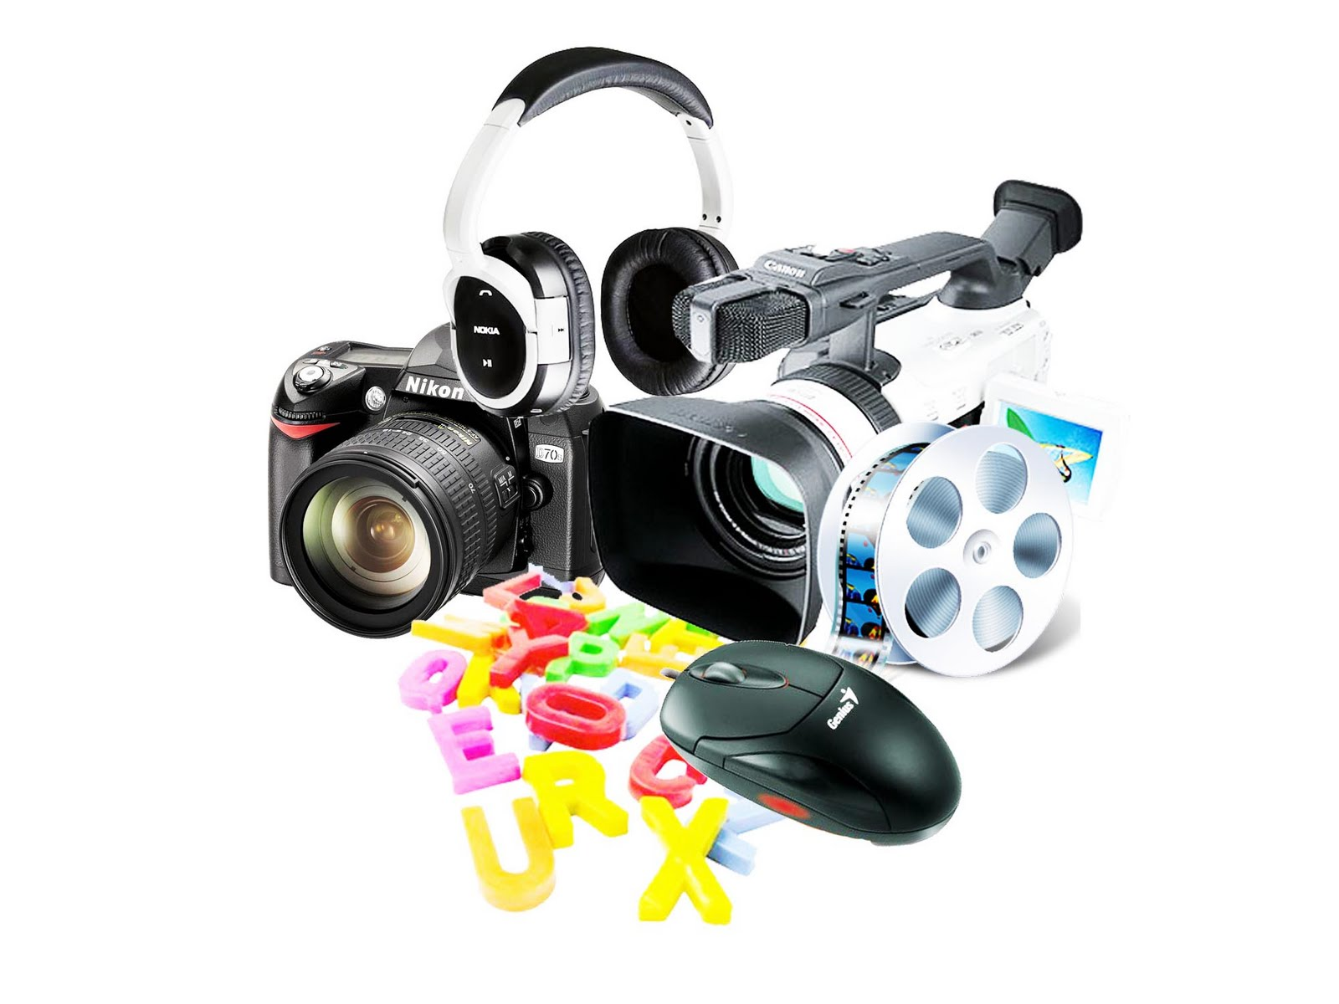

**Assignment Assessment Overview**

**Each Group should complete the following in relation to the Group work process and submit as part of your project.**

## Report & Technical Documents – 30%

* This report should include your project proposal, details of research into existing/similar products as well as existing/similar marketing techniques and campaigns, a project storyboard/wireframe, development details, any technical details, such as errors or development issues, and references (using Harvard Referencing)

## Development & Implementation – 40%

* This covers the actual development process of the marketing campaign using the technologies/elements outlined above

## Presentation – 10%

* An ‘elevator pitch’ of your product and campaign should be prepared, this should include a brief demonstration of the campaign.

## Completeness – 5%

* How close is your final project to your original proposed idea?

## Innovation – 5%

* How original is your product idea/marketing plan? How well did you implement this?

## Complexity – 10%

* Did you demonstrate your knowledge/understanding of the applications, and media tools looked at throughout the course, to the best of your ability?
* Marks will be awarded for good practices, and appropriately chosen and documented tools/techniques

## Template 1 Roles & Responsibilities

**Roles & Responsabilities**



In order for the group to work effectively it is necessary for members to take responsibility for specific tasks. Assign a group member to each of the roles. If a group member is not performing their role this must be managed within the group. If this cannot be addressed within the group please contact one of your Project lecturers as soon as possible.

|  |  |  |
| --- | --- | --- |
| Role | Responsibility | Team Member |
| Chairperson | Ensures each member remains on task and ensures that all members have a voice | Aaron Fitzgerald |
| Time Keeper | Ensures that all tasks are completed on schedule and that meeting time is used appropriately | Azeez/Aaron |
| Record Keeper | Ensures that all ideas are documented and templates are completed | Azeez Yusuff |

|  |
| --- |
| What are you being asked to do? Have you finalised on your subject area for your website? For the purpose of this project, you are expected to create an innovative product, company or service and create a promotional digital multimedia campaign for it.  The campaign must have a responsive elements e.g Facebook and twitter. The campaign must have an animation element such as html 5 or Flash etc.  It must have a Graphical element such as a logo and trademark. Also It should have one other digital element like YouTube videos, code.  So basically the project is asking us for all of the multimedia application we have used. We should put everything together and create a good website for the campaign we want to do. Also we need to work on our ideas on how the website will look like and what is our goal for the campaign we pick.  We have finalised the subject area that out website will be on and how will we use multimedia for it. The subject area we will be working on our project is a football news/comedy website. |
| Your target customer & the problems you are solving? We thought about the campaign or the website we want to work on as a group. It was hard to pick because we came up with four ideas on what we thought our campaign can be about. We have a dancing competition to advent dancing we knew there isn’t much people in our opinion really interesting in that and we won’t get a lot of target audience. We came up with a superhero idea also which didn’t seem to be the campaign we will like to do and the target audience here is low because kids are the main target in this.  We came up with football news/comedy because we knew that we will get a lot of target audience because 3.5 Billion watch the game and they love reading about the game (topendsport, 1997-2014).  With football we knew will be mostly targeting men, teenagers and a lot of people interested in sporting in general around the world. We have a comedy element also which will target everyone because everyone likes some jokes and having a laugh from time to time. Also the age target is everyone because young and old watch the game and they all read about it.  So the problem will I solving is to make people happy with our campaign because it will be a really interesting site. We will be up loading new /comic every week on the new that goes on every week in football game. |
| Differentiation and branding plan Our football information/comedy website will definitely be one that is different. We have elements that are funny, entertaining and original. The content on our page will be displayed on a very clean, crisp and clear interface with minimal obstruction. The focus will be on the users and delivering a pleasurable experience to them. Our site won’t be cluttered with advertisements but will focus on our very own created multimedia. We have comics that will be funny and appealing to all. Our videos will be comedy driven or will depict an actual event that has taken part in real life football. These elements along with providing accurate information on the top leagues is sure to make our website stand out.  In terms of our branding plan, we are determined to make this idea work and Azeez and I both have previous experience playing in and analyzing the beautiful game. We are motivated and inspired and will stop at nothing to deliver the best website possible. Our common knowledge of the sport and multimedia will bring us right to the edge of conquering our goals. There are obstacles, especially with the fact that there are a lot of football news sites out there but we see a gap in the market for a creative and innovative entry. Once we get a slice of our desired audience to view our website, we hope to see a positive reaction and they will share it with their friends which in turn will help us grow and grow. Then, through feedback and updates we will continue to refine make our site bigger and better. |

## 

|  |
| --- |
| What is the overall goal of your website? The overall goal of our website is that the clients like the website, to make sure the website does all of the functions it is meant to do , giving football news and make some comic.  So we want our websites to be dynamic and interesting so that the users get a great solution.  We will try to design the website to make sure it suits our client and to make sure our client gets an interactive and user friendly and professional look for our website. We will have good motion and graphics in the website to make it more attractive. This will help our website to get more visitors.  The main goals is to make the client happy and they enjoy the site. Functional Requirements & timeline? The functional requirement for our website will be this.   * The website have to be **responsive** so which mean that, when your website is open in a mobile phone or table it will not give the user a problem of switch to a desktop before you use or view out website. The user can view your website with not worries. * To be able to **play videos**   Your website will have some paly view which will be made by animation application online.   * To be able to also require some **intelligent links** .What we mean about intelligent links is that we will have a link to your online Facebook , twitter page for the user * **Animation:** A simulation of movement created by displaying a series of pictures, or frames which will be made on animatron.   We plan to have 3 or more element of multimedia in your site will be a **banner,** it will show football player flowing from left to right on your header of all our html page which will be made in animatron.   1. We will have **logo.** We will make our logo which we will be using Abode Firework. 2. We will have a **comic** which will be also be made in Abode firework. 3. The comic will be about funny scenarios that are either completely fictional but will star real world footballers or they will be remakes of funny/interesting things that happened on the pitch in real life.   **What will the site do?**  Our aim is that the website will do everything we want it to do, football news, comic, videos and some links.  We will have 3 html page. Which will be Home page, Video/Comic and about us.  The home will have a banner in the head section on the page, we also have a logo on the left hand side of the head. There will be a video on the home page with will be made from animatron. Also the is table in the middle of the home page of league tables  The video/comic page will have out main page which will have all the video will make yourself and also have a comic to make people enjoy the webpage. We will have same header in each page and also a footer. This page will be divide half video and comics which we design our self  The About us page will have what our website is about and if the user what to get in contact with us there is a mini form to get in touch with the user. We have out Facebook and twitter link. |
| What are the non-functional requirements of your site? Do you have a preference for the look and feel of the site? We have some preference for the look and feeling of your website. We had a meeting with the group so we will know what the website will be ad so what is the aim of the campaign will what to do on our site on.  We had to have plan and do some framework of how the website will look like also there will be few Multimedia to make the site look great also.  We had to ask our self also some few questions also before stating off how we want the users to feels when they interact with the website.   * How the flow of the website will be? * Add some galleries, Facebook/twitter box * How dynamic to our site will feel like?   We want the user to look and feel that this the website is a football news / comic site.  So here is some of the feel and look we will like the website to be friendly, professional, stylish and powerful to all the requirement from the client and your creative. |
| What other requirements do you want to achieve in your site? We have some ideas of some other requirement that we want to achieve in our website. Firstly we want to get all the requirement we want in first and the main thing multimedia. This are the some of the other things we want the website to do.   * Contact form * Social media Links * Downloading menu * Advertising  Production Log ***Adobe Fireworks Elements***   * Logo   We took this jpg H:\Semester 2\Intro Multimedia\Project Animation CA3\SoccerArmy MM Project and Presentation\SoccerArmy MM Project and Presentation\images\drogbarooney.jpgand cropped out the faces to make this pngH:\Semester 2\Intro Multimedia\Project Animation CA3\SoccerArmy MM Project and Presentation\SoccerArmy MM Project and Presentation\images\logo.png, guns were also added   * Name H:\Semester 2\Intro Multimedia\Project Animation CA3\SoccerArmy MM Project and Presentation\SoccerArmy MM Project and Presentation\images\name.pngthis was created from scratch and the ball.png was added to represent ‘O’. * Numerous images were also edited in fireworks for use in our animations in animatron. For example: This jpg   H:\Semester 2\Intro Multimedia\Project Animation CA3\SoccerArmy MM Project and Presentation\SoccerArmy MM Project and Presentation\images\defender-wall.jpg  *Was edited to these png’s H:\Semester 2\Intro Multimedia\Project Animation CA3\SoccerArmy MM Project and Presentation\SoccerArmy MM Project and Presentation\images\defenders-left.png H:\Semester 2\Intro Multimedia\Project Animation CA3\SoccerArmy MM Project and Presentation\SoccerArmy MM Project and Presentation\images\defenders.png H:\Semester 2\Intro Multimedia\Project Animation CA3\SoccerArmy MM Project and Presentation\SoccerArmy MM Project and Presentation\images\defenders-right.png*  ***Online / Social Media Elements***   * Twitter account created [Click here for Twitter page](https://twitter.com/Soccer_Army) * Facebook account created [Click here for FB page](https://www.facebook.com/SoccerArmyWebsite)   Links to our social media pages are included on our website.  ***Responsive Website Elements***  The variable grid system is a quick way to generate an underlying CSS grid for your site. The CSS generated file is based on the 1200px Grid System (1200px, n.d.).  This grid helped make our site responsive. Also, giving the correct width and height to our media elements meant that it would scale correctly.  ***Other Digital Elements***   * **Animatron**   Almost all of our animations were made using this tool   * **Blender**   Used for a dissolving animation of ‘SoccerArmy’.   * **Storyboard and Bitstrips**   Two brilliant tools we used to make and edit our comics |

**Wire Frame one**

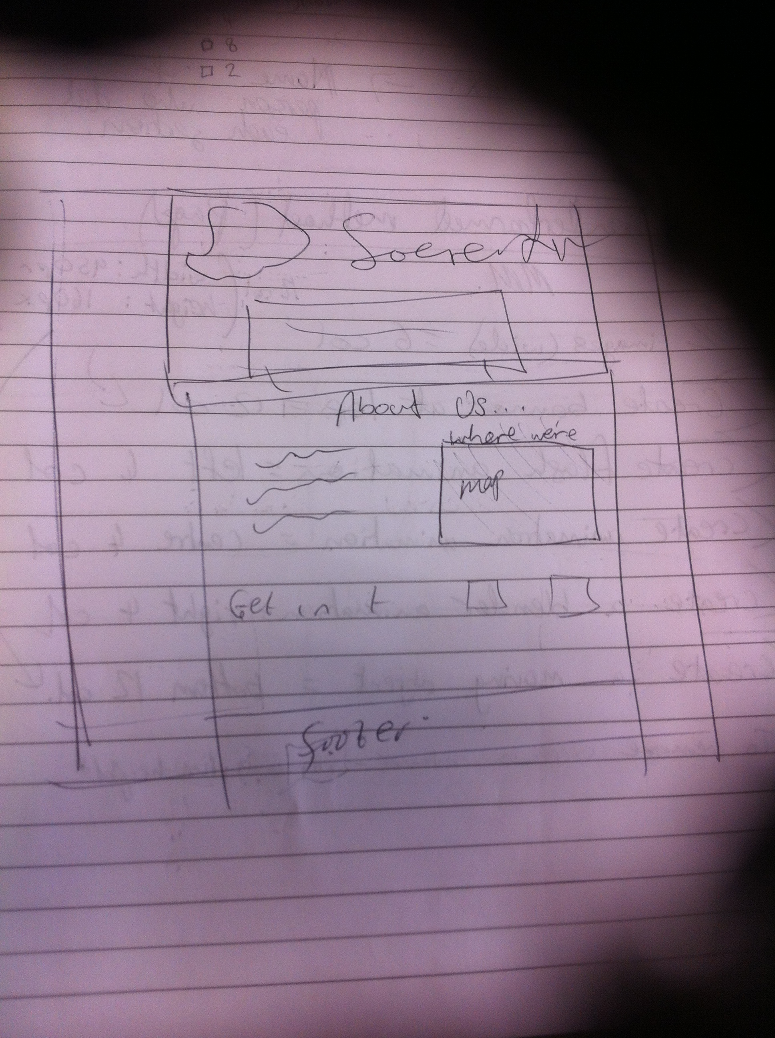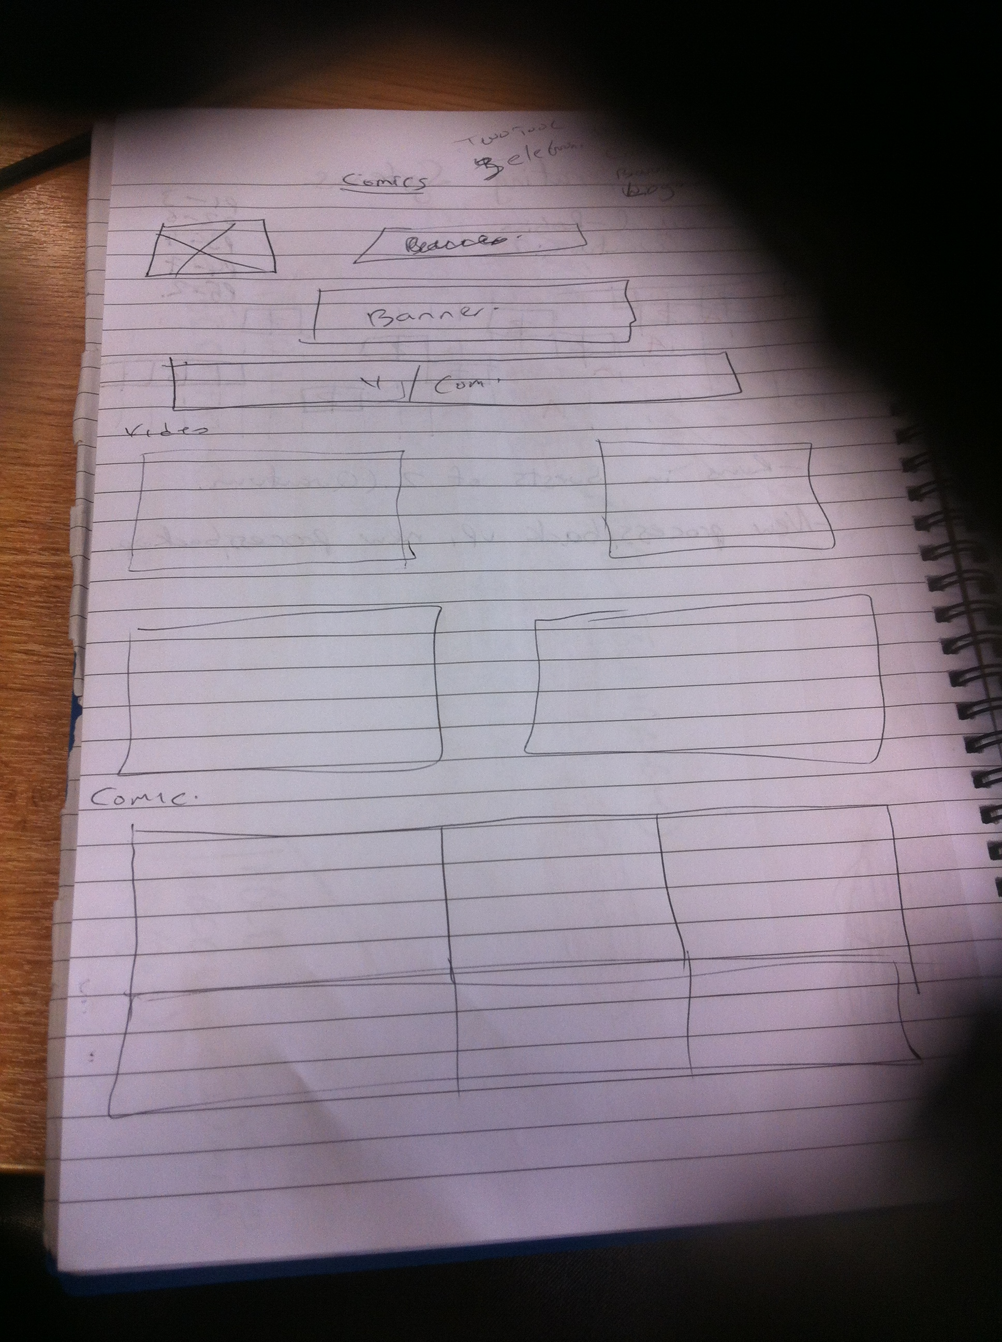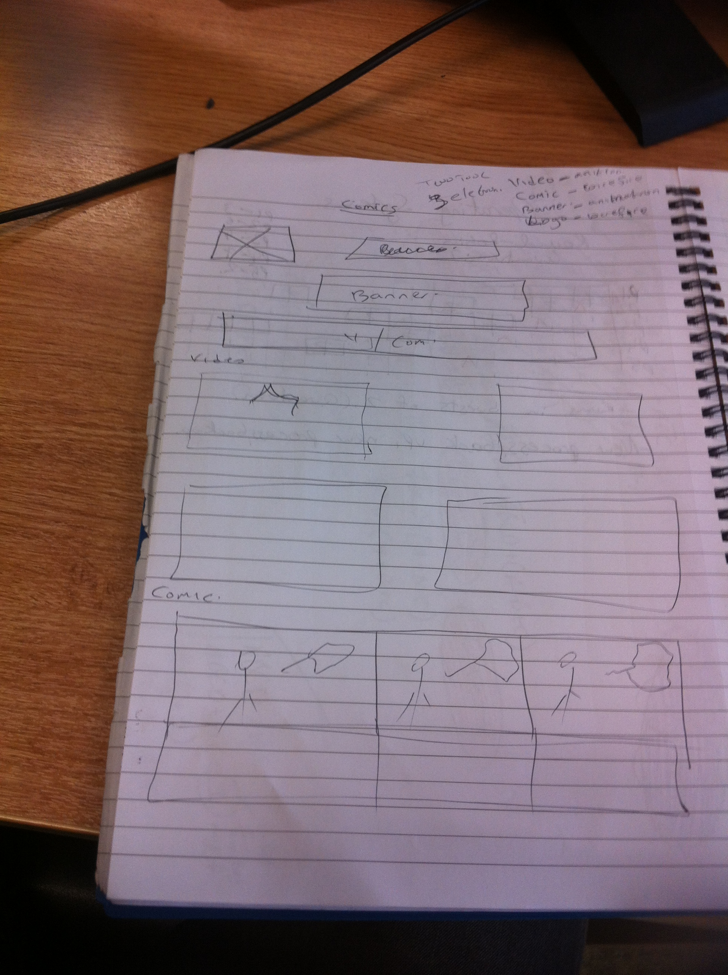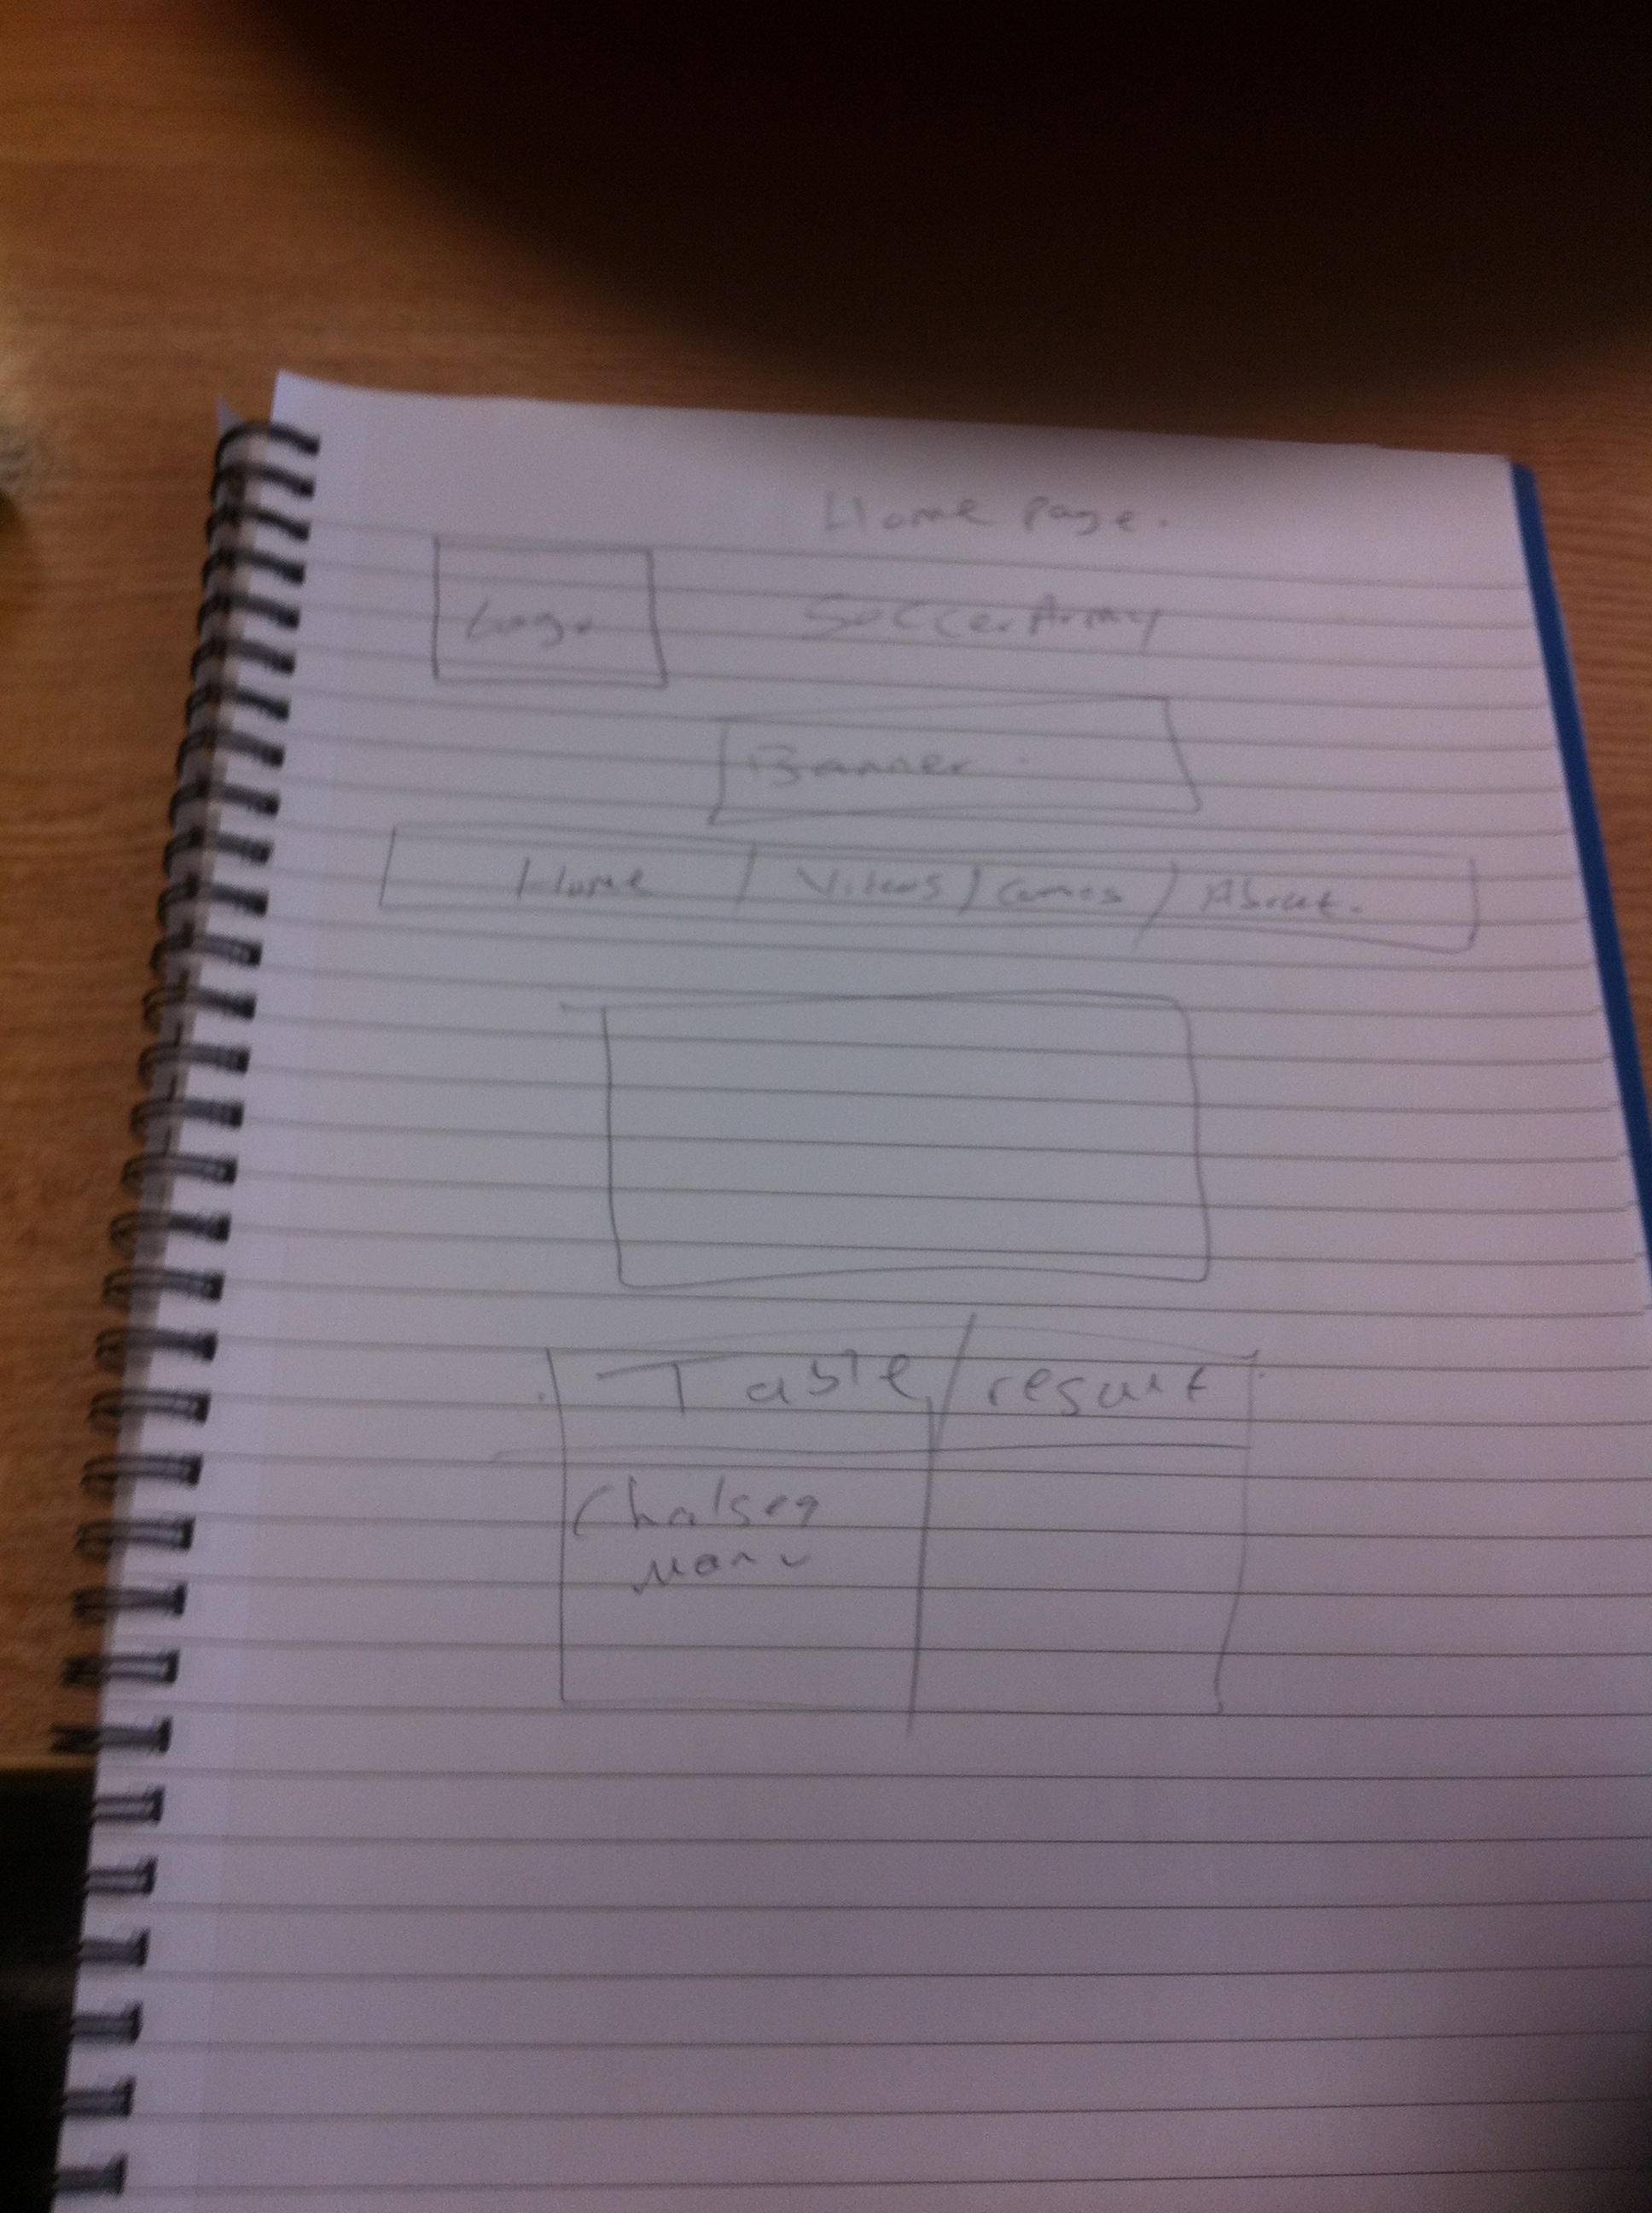

**Mock-up**

**Home page**

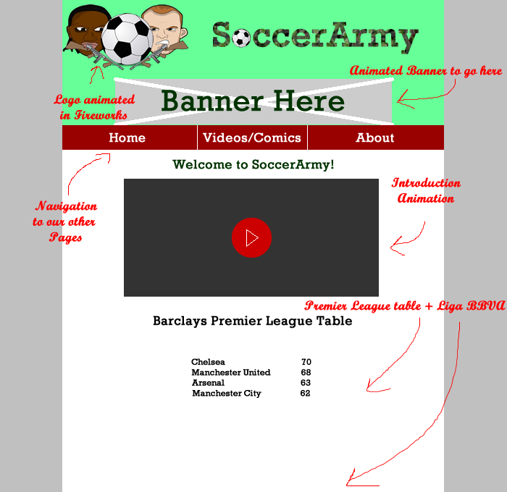

**Videos/Comics**

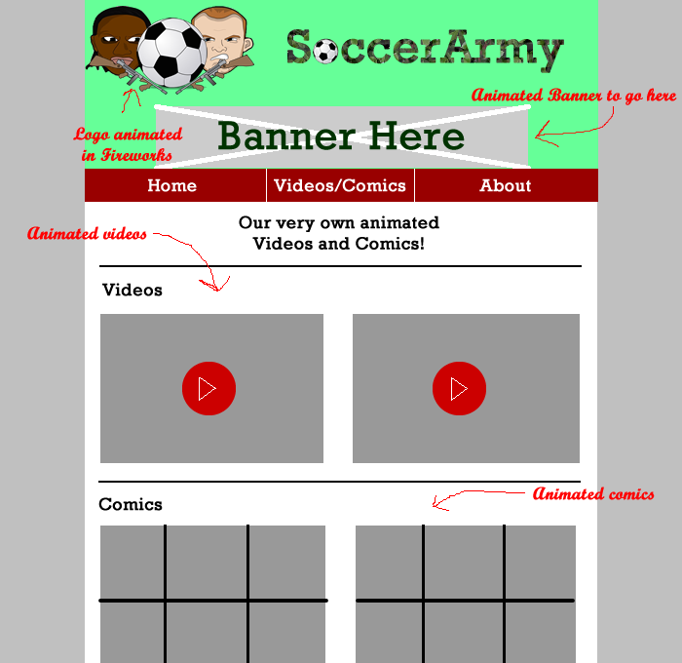

**About us page**

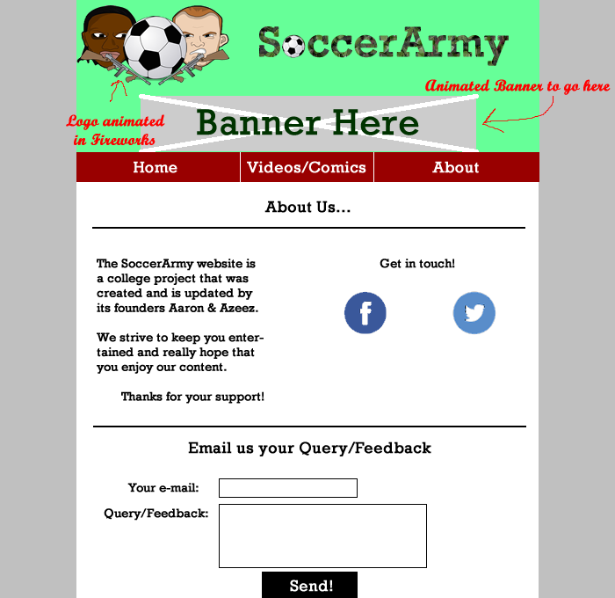

**Action Plan:**

|  |  |  |  |
| --- | --- | --- | --- |
| No. | Action | Responsibility | Completed |
| 1 | Multimedia Website Design  Project Group Process Workbook | Azeez | ✓ |
| 2 | To complete all wireframes for the webpage | Aaron | ✓ |
| 3 | Research on the campaign | Azeez | ✓ |
| 4 | Starting the logo | Aaron | ✓ |
| 5 | Starting the videos/comics page | Azeez /Aaron | ✓ |
| 6 | Validation | Aaron /Azeez | ✓ |
| 7 | Creating an animation in animatron | Aaron/Azeez | ✓ |
| 8 | Create a blender animation | Aaron | ✓ |
| 9 | Create FB and Twitter page + Links to them | Aaron | ✓ |
| 10 | Creating comics | Aaron/Azeez | ✓ |

**Template 5 Individual Action Plan**

**Group member 1 should fill in this page**

**Individual Action Plan**

Student Details: Student Name: Azeez Yusuff Student Number : x14443758

# What task(s) and information have you been assigned do.

I will be taking in charge of the multimedia Workbook. Which means I will take note all time we have a meeting. I did some research on our campaign we decide to do.

# Explain how this information may be useful in the development of the website.

The Workbook is every important because it where all the planning and idea for the website we want to build. Without the workbook I don’t know the site will be good because we will be guessing everything we do which is wrong. But by keeping the workbook and update it mean we won’t be lost.

For the research it is also important because we have to know how many people are in to football and will the site get a lot of viewers (topendsports, 1997-2014) (Sporteology, 2015)

# What are you going to feedback to the group?

I will be giving all the information I find out on the research to the group and also All of the list I say above, that will be all the feedback I will have to talk to the group about and get there opinion on it and I guess we will take all the usefully information .

**Individual Action Plan**

**Group Member 2 should fill in this page**

**Individual Action Plan**

Based on the task(s) assigned to you – record and synopsise your findings under the headings below.

Student Details: Student Name: Aaron Fitzgerald Student Number: x14715335

# What task(s) have you been assigned?

I have been assigned as the main contributor when it comes to the HTML and animation of the website. I will be using the tools available to me (Animatron, Fireworks, and Dreamweaver etc.) to make the best possible page and animations for our project.

# Explain how this information may be useful in the development of the website.

It is very important to know my role in this project as I know what areas I need to focus on and what I need to develop. Our individual tasks were assigned early which is vital for a project to be successful and to know which direction in which we are heading. Animation is obviously what the project is based on so I should do the best I can in creating appealing videos, comics and logos which I have planned.

# What are you going to feedback to the group?

I will feedback to my colleague all of the tools I have chosen to use and will confirm that he is happy with this. I will then ask him to discuss different ideas he wants me to implement before I begin animating different elements. We will hopefully come to an agreement on some common themes throughout our project. I would also like to inform him of any animation elements that I have completed and see if he would like me to make any changes.

# Conclusion

The project went well because the group worked well together. We helped each other out in and outside college. There was great communication and understanding throughout everything we done which helped us get to the final production. We feel that we achieved what we set out to do and surprised ourselves with how well we were able to complete tasks that were set out on this project. The use of the grid template that was modified to our needs helped us to picture what it would look like and place our media on our site while still being fluid and responsive.

The fact that we were able to make a website that looks very similar to our Wireframe’s gives us a great sense of achievement. We are also happy with our animations, particularly in animatron. They were fun to build for the most part but could be a pain to find out how to do something simple but we got there in the end.

If we were this start this whole project again I would like to involve some more blender animations as the 3D videos that are produced by this platform look brilliant. Also, if we had more time we would like to make the animations longer and do more complex things but we felt this wasn’t possible in our given timeframe. All in all we thoroughly enjoyed the new challenges and the project in general and feel we created a website that can be enjoyed by a mass audience on desktop/mobile.

# References

1200px, n.d. *1200px.* [Online]   
Available at: http://1200px.com/  
[Accessed 11th April 2015].

Depot, W. D., 2010-2014. *Web Designer Depot.* [Online]   
Available at: http://www.webdesignerdepot.com/2011/01/what-to-ask-a-client-before-you-start-their-project/  
[Accessed 24th November 2014].

Goodies, H., 2014. *Web Site Content - Style.* [Online]   
Available at: http://www.htmlgoodies.com/introduction/intro/article.php/3473621/Web-Site-Content---Style.htm  
[Accessed 24th November 2014].

Sporteology, 2015. *Top 10 Most Popular Sports in The World.* [Online]   
Available at: http://sporteology.com/top-10-popular-sports-world/  
[Accessed 28th February 2015].

topendsport, 1997-2014. *Top 10 list of the internet world's most populart sport.* [Online]   
Available at: http://www.topendsports.com/world/lists/popular-sport/fans.htm  
[Accessed 28th February 2015].

topendsports, 1997-2014. *The World's Most viewes Sport.* [Online]   
Available at: http://www.topendsports.com/world/lists/popular-sport/most-viewed.htm  
[Accessed 28th february 2015].

## Template 8 Peer Review

|  |  |  |  |
| --- | --- | --- | --- |
| **Main Contributor(s)**  **3D smiley 1**  **10 marks** | **Secondary Contributor(s)**  3D smiley 5  **7 marks** | **Minimal Contribution**  3D smiley 3  **3 marks** | **No Contribution**  [Picture]  **0 marks in Assignment** |
| Azeez Yusuff  Aaron Fitzgerald |  |  |  |

I Azeez Ishola Yusuff agree with the marks that have been awarded for my contribution to the assignment.

I Aaron Fitzgerald agree with the marks that have been awarded for my contribution to the assignment.